

Lingnan University

CDS 4010 Web Programming

Report

1. ER diagram 1

2. Relation schema 2

3. Database user setting 3

4. Table generated 4

4.1 Users 4

4.2. Product 5

4.3. Transaction 6

Group 5:

TAM Yuk Sum 4122014

Ng Ngai Fung 4112150

# 1. ER diagram

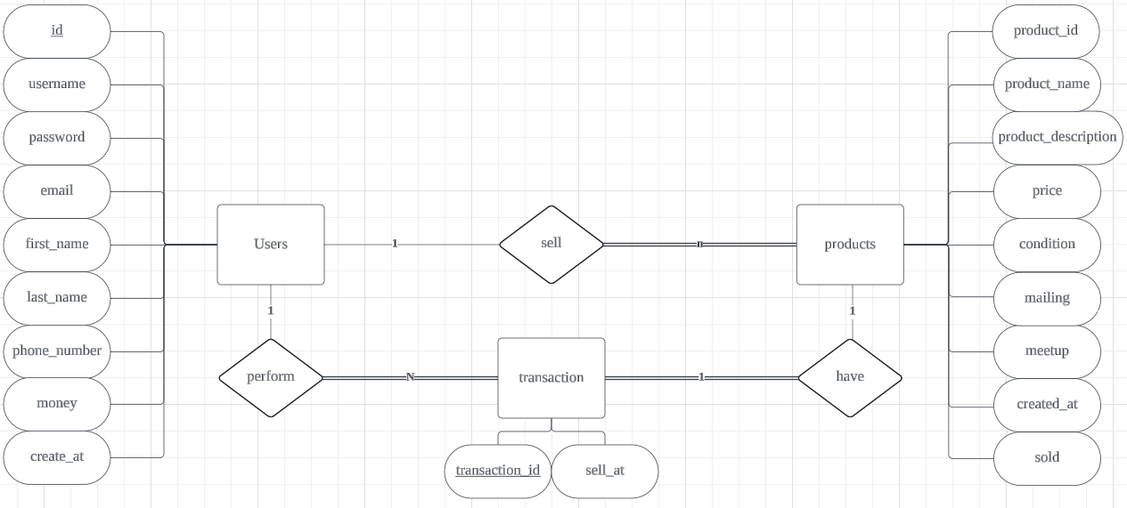1 user can sell many products. 1 user can do many transactions. 1 transaction can only contain 1 product.

To perform the transaction, all transaction information is needed which means transaction fully patriciate in the ordering process and product matching process

If the user wants to sell a product, the user needs to fill in all product information which means product fully patriciate in the selling process

# 2. Relation schema

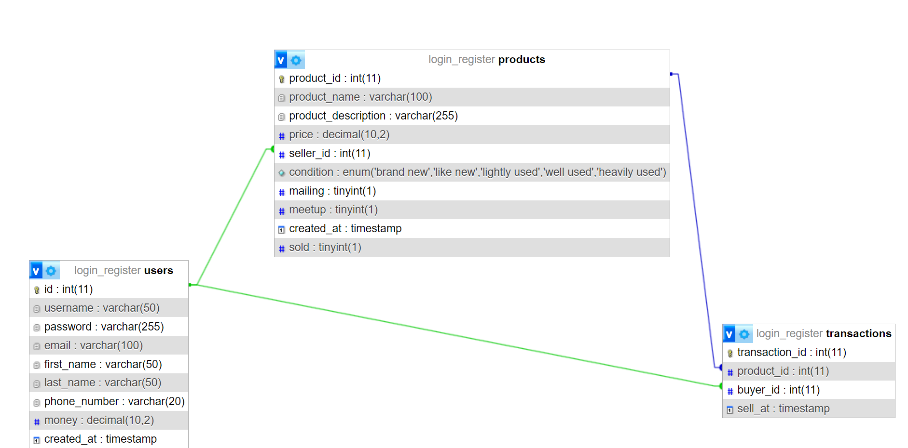Users table: It is the table where we store our customers' information, such as password, email, phone_number.

Products table: This is the table where we store the information of the product that sell by other users. Therefore, the seller_id is a foreign key that is related to the users’ id. It is worth noticing that there is an attribute called “sold”. There are sold = 0 means the product are not sold yet. When sold = 1, which means that the product is sold, and it will not display to others on the webpage anymore, it is already sold out. So that we can keep the records in the database and the transaction records. In other words, we can still check what transactions are made, and what product it is.

Transactions table: This table will store what product and who purchase the product. Thus, the product_id and buyer_id will be the foreign key, it related to the products’ product_id and users’ id reprehensively.

# 3. Database user setting

**Php admin setting**

Host Name = localhost

User Name = admin

DataBase Password = 12345

DataBase Name = login_register

# 4. Table generated

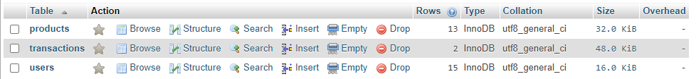There are 3 table generated. They are highly related together.

## 4.1 Users

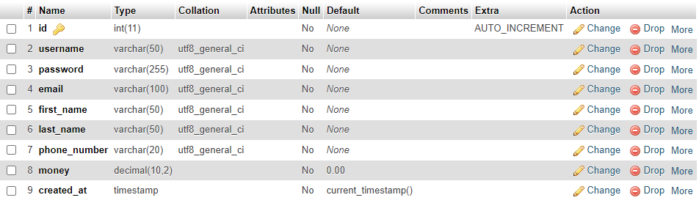”users” is used to store customers information:

* id: auto_increment and it is primary key. It is used to identify users.
* Username: usually display name in system. Since usually the username would not be so long. Therefore, varchar(50) will be suitable.
* Password: the password that login system needed, since we are storing hashing passwords, the password will be much longer after hashing. Therefore, Varchar(255) will be used.
* Email: users’ email, since email usually would not be too long, so Varchar(50) is enough.
* First_name: users’ first name, usually not too long.
* Last_name: users’ last name, usually not too long.
* Phone_number: users’ phone number. Since there are impossible for a phone that will be longer than 20. Therefore, varchar(20) should far enough for nowadays situations.
* Money: storing users account money (simulation)
* Create_at: timestamp, record the create time.

## 4.2. Product

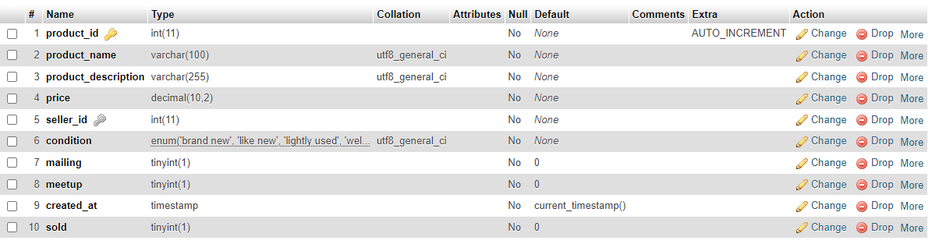”products” is used to store the product which sold by users:

* Product_id: auto_increment and it is primary key. It is used to identify products.
* Product_name: product’s name, some product may have a bit more letters. Therefore, varchar(100) is set.
* Product_description: for seller to describe there product.
* Price: the price of product. Since monetary values require precise representation to ensure accurate calculations, decimal(10,2) is set.
* Seller_id: is a foreign key, which related to the users table. Since in a two hand goods market web platform, buyers can be sellers, sellers can also be buyers.
* Condition: only store five class (brand_new, like_new, lightly_used, well_used, heavily used). Thess five classes are copied from Carousell.
* Mailing: if able to mailing, the binary will be 1, else 0.
* Meetup: if able to meetup, the binary will be 1, else 0.
* Create_at: timestamp. Just a record of when the product is displayed.
* Sold: if the product is sold, then the binary will become 1, and the product would not show on the website. Instead of deleting the product from the database, it is better to keep in the database, so that we can keep tracking the record after the transaction.

## 4.3. Transaction

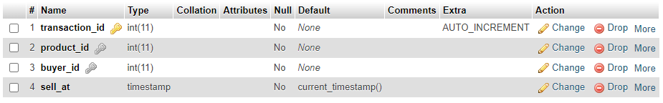”Transaction” is used to store the record that when and what users purchased:

* Transaction_id: auto_increment and it is primary key. It is used to identify products.
* Product_id: foreign key, related to the product_id from product table.
* Buyer_id: foreign key, related to the id from the users table.
* Sell_at: timestamp, used to record when the transaction was made.